|  |  |  |  |
| --- | --- | --- | --- |
| **Name of Student: Pushkar Sane** | | | |
| **Roll Number: 45** | | **Practical Number: 10** | |
| **Title of Lab Assignment: Demonstrate features of Angular forms with a Program.** | | | |
| **DOP: 23-09-2023** | | **DOS: 24-09-2023** | |
| **CO Mapped:**  **CO5** | **PO Mapped:**  **PO3, PO5, PSO1, PSO2** | **Faculty Signature:** | **Marks:** |

**Practical No. 10**

**Aim:** Demonstrate features of Angular forms with a Program.

**Description:**

For reference: YouTube playlists for explanation of the code

**Hindi:** https://www.youtube.com/playlist?list=PL8p2I9GklV45--5t7_N4lveUI6Y31vQ6C

(Watch videos #35 to #37)

OR

**English:** https://www.youtube.com/playlist?list=PL8p2I9GklV47eNpoo4Fr6fkags72a8F0v

(Watch videos #34 to #37)

Angular is a popular web application framework that provides a variety of features for building dynamic and interactive web applications. Angular forms are a critical part of this framework, allowing developers to capture and handle user input. Here are some of the key features of Angular forms:

1. **Template-driven forms:**

Angular offers a template-driven approach for creating forms, which is suitable for simpler forms with less complex logic.

Forms are defined within the template HTML and are bound to the component using ngModel directives.

1. **Reactive forms (Model-driven forms):**

Reactive forms are more flexible and suitable for complex forms with extensive validation and custom logic.

They are defined programmatically in the component class, offering full control over form behavior and validation.

1. **Two-way data binding:**

In template-driven forms, Angular provides two-way data binding using ngModel, allowing data to flow seamlessly between the template and component.

1. **FormControl and FormGroup:**

Reactive forms use FormControl and FormGroup classes to represent form controls and groups of controls.

FormControl represents an individual input field, while FormGroup is used to group related form controls together.

1. **Validation:**

Both template-driven and reactive forms support client-side validation with built-in validators like required, minLength, maxLength, pattern, and custom validators.

Validation messages can be displayed based on the form's state and user interactions.

1. **Asynchronous validation:**

Reactive forms allow you to perform asynchronous validation, such as checking data on a server or making HTTP requests before allowing form submission.

1. **Dynamic form controls:**

You can dynamically add, remove, or modify form controls at runtime based on user interactions or other criteria.

1. **FormArray:**

Reactive forms include FormArray, which allows you to work with dynamic lists of form controls, like repeating form fields or dynamic form sections.

1. **Error handling:**

Angular provides mechanisms for handling and displaying form errors and validation messages, making it easier for users to understand and correct input issues.

1. **Form submission:**

Angular forms provide mechanisms for handling form submission, whether it's sending data to a server via HTTP requests or performing actions on the client side.

1. **ngSubmit:**

Both template-driven and reactive forms support the ngSubmit directive, which allows you to define a function to be executed when the form is submitted.

1. **Template-driven form features:**

Features specific to template-driven forms include ngModel, ngModelGroup, ngForm, and ngModelChange for custom event handling.

1. **Reactive form features:**

Features specific to reactive forms include FormBuilder for simplifying form control creation, custom validators, value changes observables, and more control over the form's behavior.

1. **Demonstrate features of Angular forms with a program**

**Steps to execute the practical:**

1. Create a folder “practical 10”
2. Open the terminal (please use cmd, avoid using powershell) and navigate the “practical 10” folder by using the cd command
3. Create a new angular project by running the following command

ng new prac10

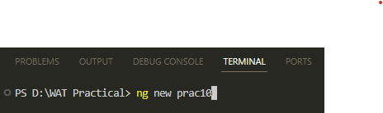

1. When prompted for Angular Routing, Enter “y”

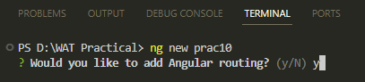

1. When prompted for CSS, use arrow keys to select “CSS” (it is the first option and is selected by default) and then press Enter

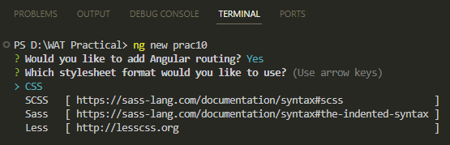

1. The new Angular project is created

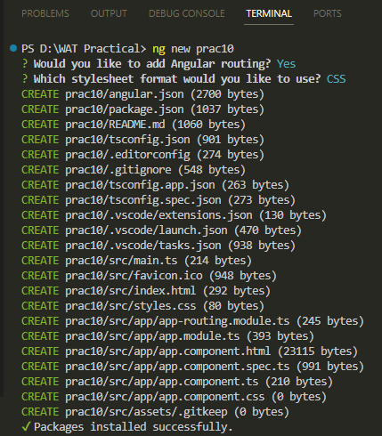

1. Navigate to the prac10 folder by using the cd command

cd prac10

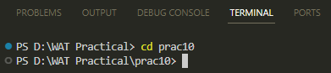

1. Create a new component “registration” by running the following command. This

registration component will be our registration form

ng generate component registration

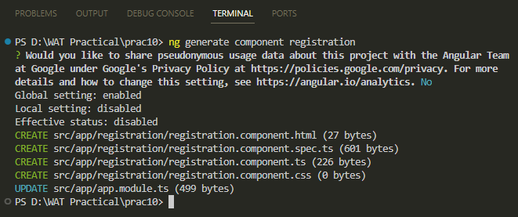

1. Run the following command to serve the angular project on a server

ng serve

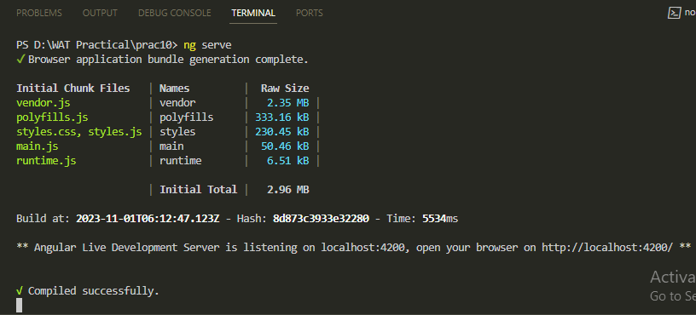

1. The server is running and will automatically re-compile the project when we make any changes
2. Open any browser and go to the following link to see the output (this is the default output whenever any new Angular project is made)

<http://localhost:4200/>

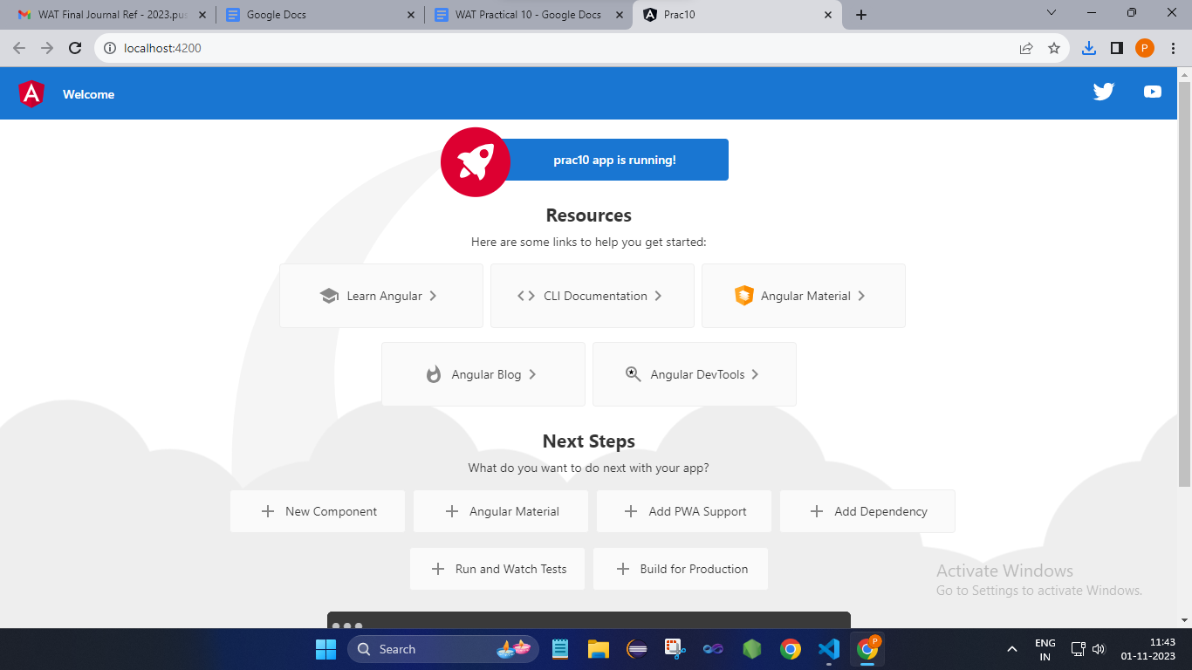

1. We will add the ReactiveFormsModule to the **app.module.t**s file in the

prac10/src/app/ folder

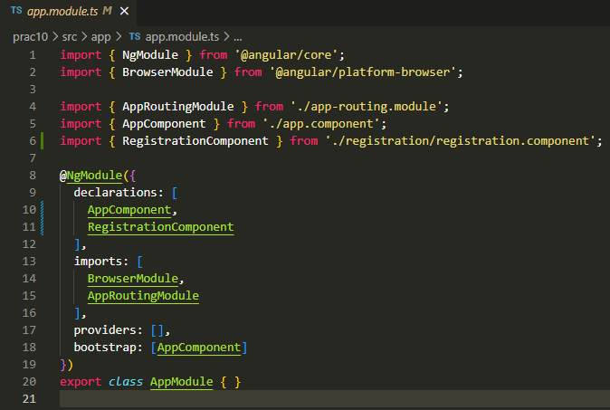

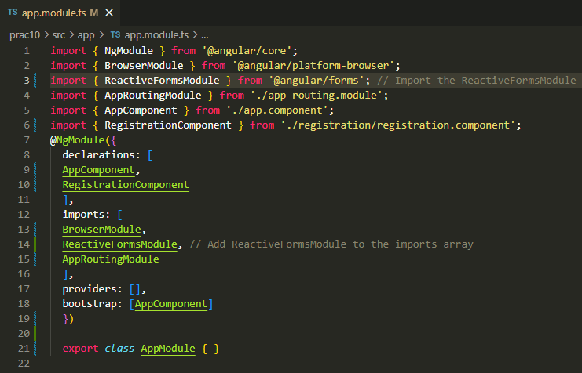

After making the changes, the **app.module.ts** file should look like this:

import { NgModule } from '@angular/core';

import { BrowserModule } from '@angular/platform-browser';

import { ReactiveFormsModule } from '@angular/forms'; // Import the ReactiveFormsModule

import { AppRoutingModule } from './app-routing.module';

import { AppComponent } from './app.component';

import { RegistrationComponent } from './registration/registration.component';

@NgModule({

declarations: [

AppComponent,

RegistrationComponent

],

imports: [

BrowserModule,

ReactiveFormsModule, // Add ReactiveFormsModule to the imports array

AppRoutingModule

],

providers: [],

bootstrap: [AppComponent]

})

export class AppModule { }

1. Add the “registration” component to the app.component.html file

Delete all the contents of **app.component.html** file (located in the prac11/src/app/ folder)

Add the following code to the file and save it

<app-registration></app-registration>

1. Now we’ll make the registration form.

We will make changes to the following 3 files in the “registration” folder

(prac10/src/app/registration/)

registration.component.ts

registration.component.html

registration.component.css

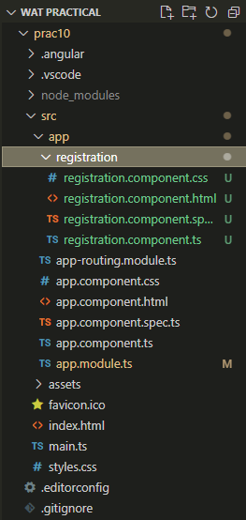

1. We’ll modify the registration.component.ts file in the prac10/src/app/registration folder

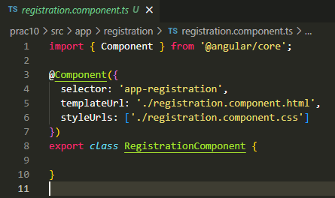

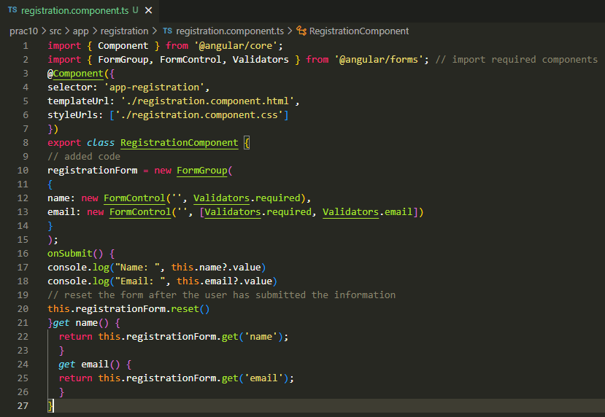

After making the changes, the **registration.component.ts** file should look like this:

import { Component } from '@angular/core';

import { FormGroup, FormControl, Validators } from '@angular/forms'; // import required components

@Component({

selector: 'app-registration',

templateUrl: './registration.component.html',

styleUrls: ['./registration.component.css']

})

export class RegistrationComponent {

// added code

registrationForm = new FormGroup(

{

name: new FormControl('', Validators.required),

email: new FormControl('', [Validators.required, Validators.email])

}

);

onSubmit() {

console.log("Name: ", this.name?.value)

console.log("Email: ", this.email?.value)

// reset the form after the user has submitted the information

this.registrationForm.reset()

}get name() {

return this.registrationForm.get('name');

}

get email() {

return this.registrationForm.get('email');

}

}

1. Delete all the default generated code in registration.component.html file in the prac10/src/app/registration folder.

Write the following code in registration.component.html

<h1>Registration Form</h1>

<form [formGroup]="registrationForm" (ngSubmit)="onSubmit()">

Name: <input type="text" formControlName="name">

<p class="error-message" *ngIf="name?.touched && name?.invalid">Name is invalid</p>

<br>

Email: <input type="email" formControlName="email">

<p class="error-message" *ngIf="email?.touched && email?.invalid">Email isinvalid</p>

<br>

<button [disabled]="registrationForm.invalid">Submit</button>

</form>

1. Save the registration.component.html file.
2. Open the registration.component.css and add the following code in it:

.error-message {

color: red;

}

1. Save the registration.component.css file
2. Go to the browser to see the output at <http://localhost:4200/>

Press the following keyboard shortcut to see the console in the browser

Ctrl + Shift + J

**Registration Form Output**

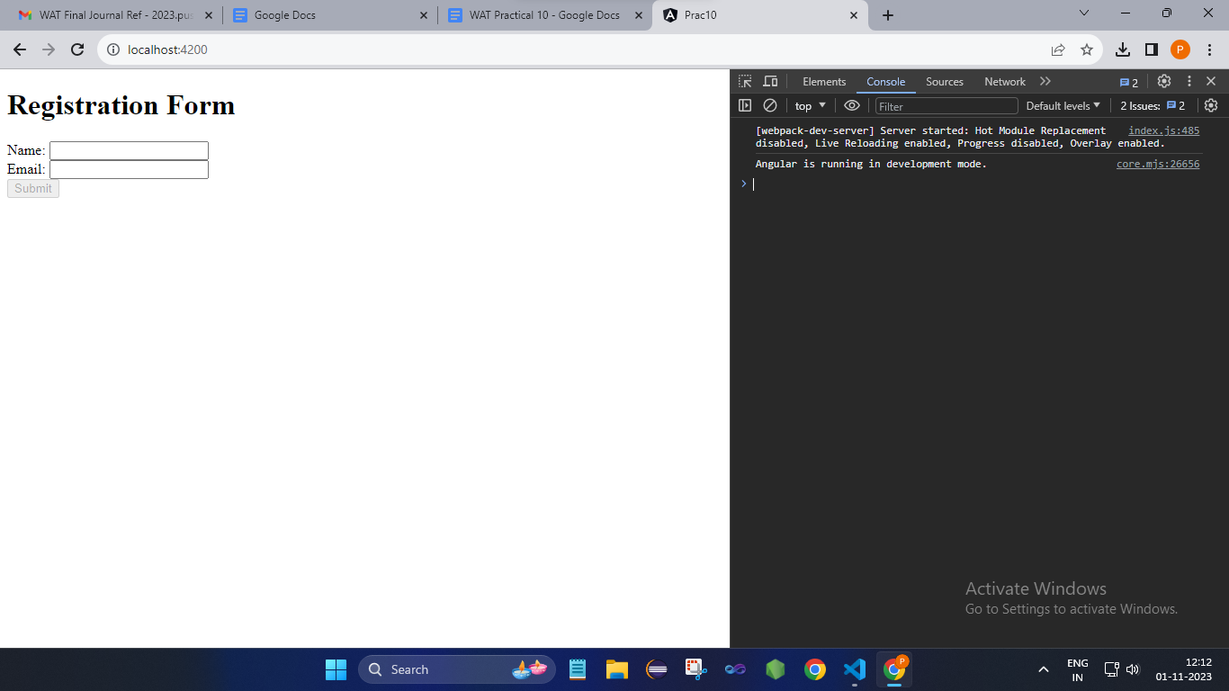

Click on the input boxes and then click outside the boxes to see the form validation

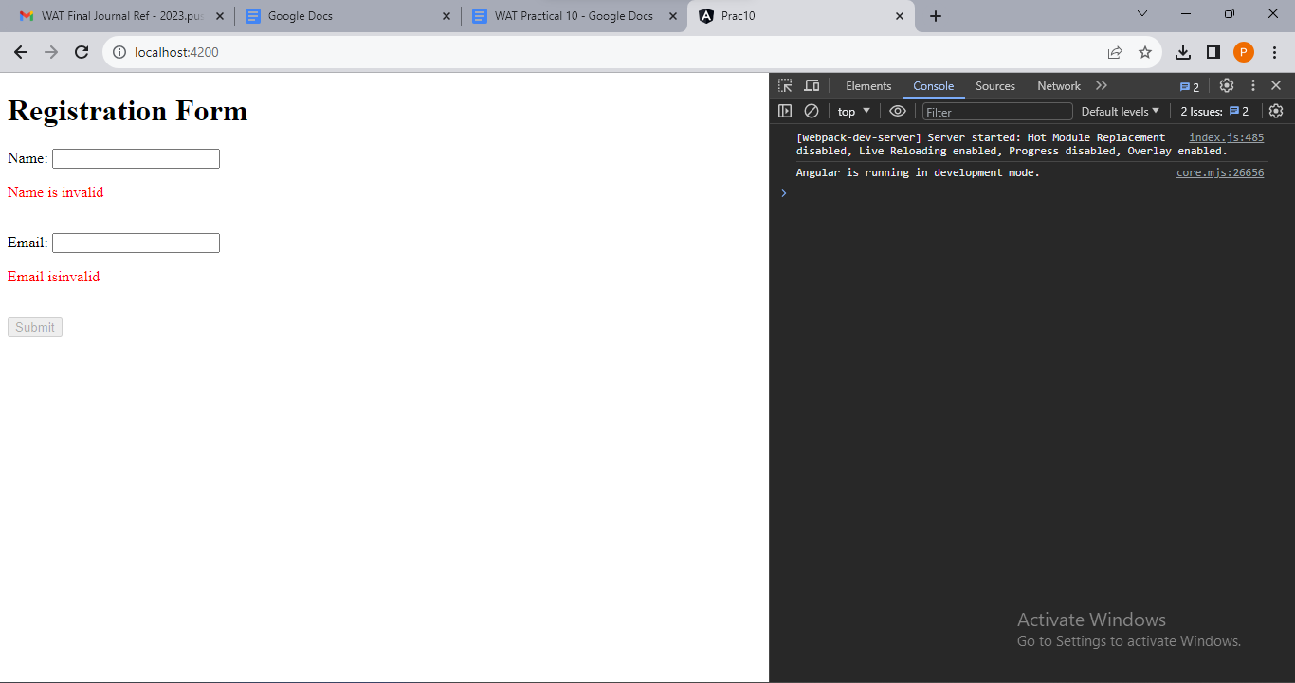

Type all valid input values to enable the Submit Button

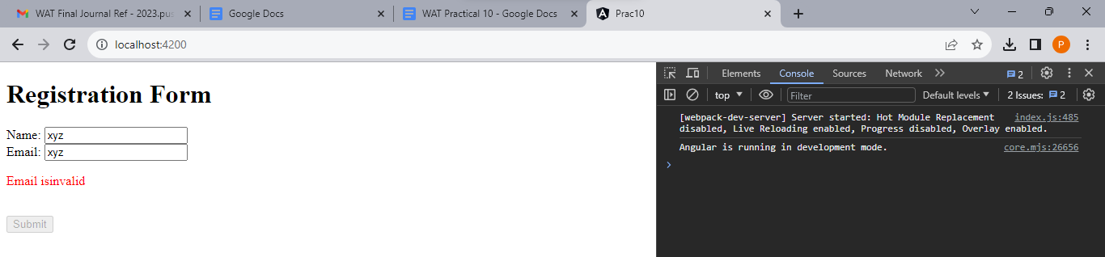

Type all valid input values to enable the Submit Button

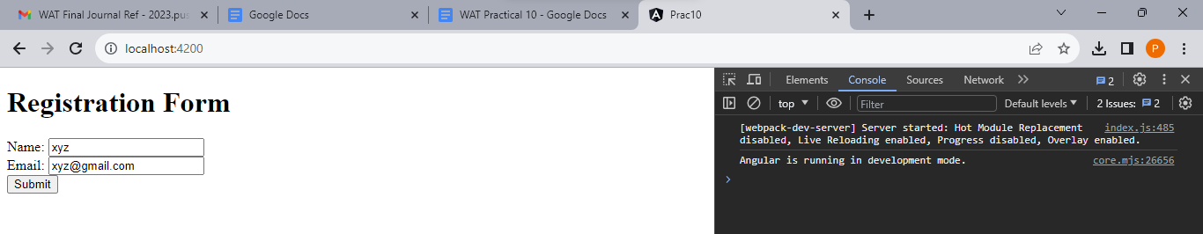

Submit the form to see the values in the console

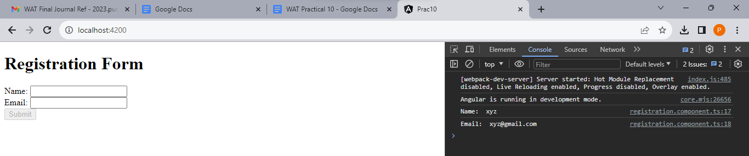

1. Go to the terminal and stop the server by pressing Ctrl + C

When we see the prompt as “....\prac10>” then it means that the server has stopped

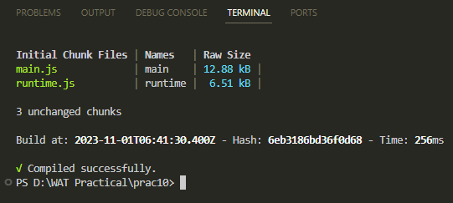

**Code:**

**app.module.ts**

import { NgModule } from '@angular/core';

import { BrowserModule } from '@angular/platform-browser';

import { ReactiveFormsModule } from '@angular/forms'; // Import the ReactiveFormsModule

import { AppRoutingModule } from './app-routing.module';

import { AppComponent } from './app.component';

import { RegistrationComponent } from './registration/registration.component';

@NgModule({

declarations: [

AppComponent,

RegistrationComponent

],

imports: [

BrowserModule,

ReactiveFormsModule, // Add ReactiveFormsModule to the imports array

AppRoutingModule

],

providers: [],

bootstrap: [AppComponent]

})

export class AppModule { }

**app.component.html**

<app-registration></app-registration>

<router-outlet></router-outlet>

**registration.component.ts**

import { Component } from '@angular/core';

import { FormGroup, FormControl, Validators } from '@angular/forms'; // import required components

@Component({

selector: 'app-registration',

templateUrl: './registration.component.html',

styleUrls: ['./registration.component.css']

})

export class RegistrationComponent {

// added code

registrationForm = new FormGroup(

{

name: new FormControl('', Validators.required),

email: new FormControl('', [Validators.required, Validators.email])

}

);

onSubmit() {

console.log("Name: ", this.name?.value)

console.log("Email: ", this.email?.value)

// reset the form after the user has submitted the information

this.registrationForm.reset()

} get name() {

return this.registrationForm.get('name');

}

get email() {

return this.registrationForm.get('email');

}

}

**registration.component.html**

<h1>Registration Form</h1>

<form [formGroup]="registrationForm" (ngSubmit)="onSubmit()">

Name: <input type="text" formControlName="name">

<p class="error-message" *ngIf="name?.touched && name?.invalid">Name is invalid</p>

<br>

Email: <input type="email" formControlName="email">

<p class="error-message" *ngIf="email?.touched && email?.invalid">Email isinvalid</p>

<br>

<button [disabled]="registrationForm.invalid">Submit</button>

</form>

**registration.component.css**

.error-message {

color: red;

}

**Reference for explanation of the code**

Hindi: <https://www.youtube.com/playlist?list=PL8p2I9GklV45--5t7_N4lveUI6Y31vQ6C>

(Watch videos #35 to #37)

OR

English: <https://www.youtube.com/playlist?list=PL8p2I9GklV47eNpoo4Fr6fkags72a8F0v>

(Watch videos #34 to #37)

**Output:**

**Console**



**Browser:**

**Press Ctrl + Shift + J to see the console**

**Registration Form Output**



**Click on the input boxes and then click outside the boxes to see the form validation**



**Type an invalid email to see the email’s validation**



**Type all valid input values to enable the Submit Button**



**Submit the form to see the values in the console**



**Conclusion:** We learnt about forms in Angular js.